  
  
  
  
  
  
  
  
Enabling Vessel IMO Number Match

International Registries, Inc.

**Document Control Information**

**Document Information**

|  |  |
| --- | --- |
| Document Identification | <Insert document ID, if applicable> |
| **Document Name** | Enabling Vessel IMO Number Match |
|  |  |
| **Project Name** | Oracle Watchlist Screening (OWS) |
| **Client** | IRI |
| **Document Author** | Priyank Chauhan |
| **Document Version** | 0.1 |
| **Document Status** | **Revised Requirement** |
| **Date Released** |  |

**Document Edit History**

|  |  |  |  |
| --- | --- | --- | --- |
| Version | Date | Additions/Modifications | Prepared/Revised by |
| 0.0 | Oct, 2020 | Draft version | Priyank Chauhan |
| 0.1 | Nov, 2020 | Revised version | Priyank Chauhan |
|  |  |  |  |
|  |  |  |  |

**Document Review/Approval History**

|  |  |  |  |
| --- | --- | --- | --- |
| Date | Name | Organization/Title | Comments |
|  |  |  |  |
|  |  |  |  |
|  |  |  |  |
|  |  |  |  |
|  |  |  |  |

**Distribution of Final Document**

The following people are designated recipients of the final version of this document:

|  |  |
| --- | --- |
| Name | Organization/Title |
|  |  |
|  |  |
|  |  |
|  |  |

Table of Contents

1. Project Overview 4

2. Purpose 4

3. Scope 4

3.1. In Scope 4

4. Business Requirements 4

4.1. Analysis 4

4.2. Current Results 5

5. Solution 5

# Project Overview

International Registries, Inc. (IRI) is using Oracle Watch List Screening Solution. Oracle has implemented the Watchlist Management and Watchlist Screening (3 bucket solution) Solutions. Inspirage is engaged with IRI for development and support of OWS solution. Inspirage is helping with enhancement and optimization of current solution. Inspirage has developed SAN Watchlist Screening (1 Bucket Solution). Inspirage has been engaged by IRI for requirement gathering and solution design for Vessel IMO Number Match. Currently we are getting results for Vessel name and we are planning to modify the solution for matching based on Vessel Name and IMO Number or either of one.

# Purpose

This document captures updated requirement for Enabling Vessel IMO Number Match.

# Scope

The section below explains broadly what is in scope for Enabling Vessel IMO Number Match.

## In Scope

* Vessel IMO Number Match should return matching results based on below inputs.
  + **Vessel Name and Vessel Indicator**
  + **Vessel Indicator and IMO Number**
  + **Vessel Name, Vessel Indicator and IMO Number**

# Business Requirements

As per the previous requirement we enabled users to search for Vessel Info based on both Vessel Name and IMO Numbertogether or any one of them for match. Now as per the new requirement we are restricting the search only for vessel by using Vessel Indicator. So user need to pass Vessel Indicator with Vessel Name or IMO Numberor any one of them for match.

## Analysis

We passed the Vessel Name and IMO Number but it has resulted 4 non-vessel results.   
Vessel Name - **Topaz Glory** IMO Number – **9560297**

Below is the screenshot for webservice tester output.

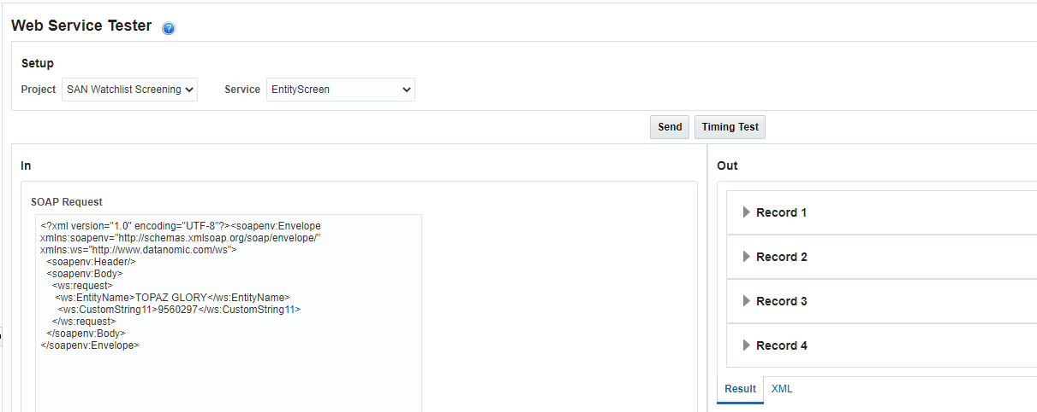

## 4.2. Current Results

We were returning the Vessel and Entity matches based on the name. In case if we pass Vessel Name or IMO Numberor any one of them than it will check the matching results for Vessel as well as Entity.

Vessel Name - **SNOW** IMO Number – **9569619**

Below is the screenshot for webservice tester output.

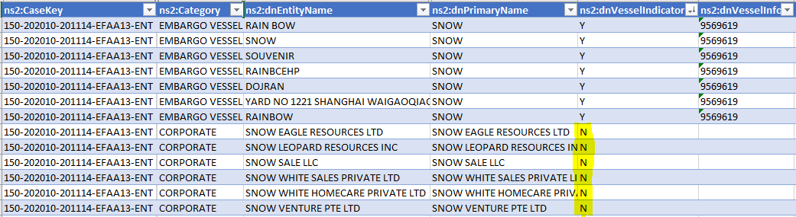

# Solution

Enabling Vessel IMO Number Match will allow users to search the Vessel and get the Vessel information using IMO number. Previously we are getting results based on Vessel Name and IMO Numberor any one of them. The results were including Vessel and Entity matches.

As per the new requirement, only the vessel results should be returned So we are making the Vessel Indicator as a mandatory input field for Vessel search. We will allow users to search based on Vessel Indicator and Vessel Name or IMO Number or combination of both and all the match results will be exact matches.

Input Example : -

Vessel Name IMO Number Vessel Indicator

Topaz Glory 9560297 Y

9560297 Y

Topaz Glory Y

We will use **CustomString11** as input for **IMO Number** and **CustomString10** as input for **Vessel Indicator**.